Corica Park Golf Course
Corica Park Golf Course is located on the picturesque island of Alameda, California, less than five minutes from Oakland Airport. Time to find one of America's best public access courses, South Course. Unlike any other study in the Bay Area, renowned architect Rees Jones describes the new study as a minimalist design in a way you can find in Australia, where you can play ball in a hole in the air or on the floor.
The new Corica Park Golf Course at Corica Park also known as the Jack Clark course opened in the summer of 2018, after a spectacular restoration under the watchful eye of renowned artist Rees Jones. The new building follows the same pattern as the existing one, but now it is playing fast and solid, with some of the world-famous Australian Sand belt lessons. Golfers now have many options to play each way to the green, whether they run a hybrid or float on a short pole. And best of all, the study is playable even in the harshest winters because of the improved drainage system and water recovery techniques. In addition, an environmentally friendly project where fewer chemicals are needed - even cart tracks are built using recycled materials.
History:
Corica Park has a long history immersed in the tradition of providing stellar public golf courses and unique service. The 45-hole facility has had a few names over the years, including the Alameda Municipal Golf Course and the Chuck Corica Golf Complex, a moniker taken in honor of the former Alameda mayor in 1992. In 1997, the name was abbreviated to Corica Park.
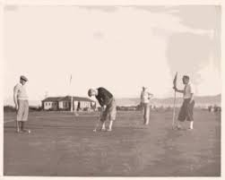
Founded in 1927, William Park Bell, often referred to as the "grandfather of golf design," created the first 18-hole golf course, now known as the North Course. In 1967 the courses were partially reorganized by Desmond Moorhead. With tree-lined roofs and water play in 13 holes, this parkland study has attracted golfers since its inception. The study is currently underway, with a focus on the full reopening of 2022.
Restaurants:
Jim's coffee shop has been in the city of Alameda for over 60 years. Their Corica Park area, dubbed "Jim's on the Course", offers such a varied delicacies that the hardest part is finding the right one. Enjoy breakfast, lunch, and the 19th hole where you will feel like you have entered your local “area” for a beer. If you want to know what’s going on in Alameda, Jim’s On The Course is a meeting place. Come hungry.
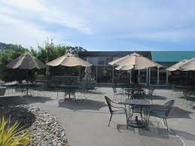
Golf Courses:
South Course: The South Course was designed and designed by renowned golfer Rees Jones. The style behind the Australian sand band studies, the Alameda Corica Park South Course is the only one of its kind by Rees Jones in the Bay area. Environmental factors include: improved water transport and water rehabilitation, modern irrigation, and drought-tolerant grasses.
North Course: Front 9 in the North Course was opened on October 14, 2021. Designed in 1927 by William Park Bell and slightly redesigned by Desmond Muirhead in 1967, the fully renovated North Course founded by the famous Australian -Greenway Golf Marc Logan, named after one of the world's most influential project / construction managers. It is slightly shorter than the South Course and will feature more dog legs and water when playing 13 holes. Back 9 will be completed by the end of 2022.

Practice Area: They say that practice makes it perfect. But more importantly, the exercise should be fun and the newly renovated Corica Park Exercise Center offers that with beautiful natural grass-covered grasses, striking beams, natural grass stations and a new world-class short- playground. The newly renovated practice areas are carefully maintained with detail.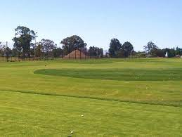
Conclusion:
Corica Park Golf Course is one of the jewels of Alameda and it has its own value among other valuable places in the district. You have to take some time and visit this amazing place.

